MODULE 8 LLOYD BONDS SCREENSHOTS
18.5
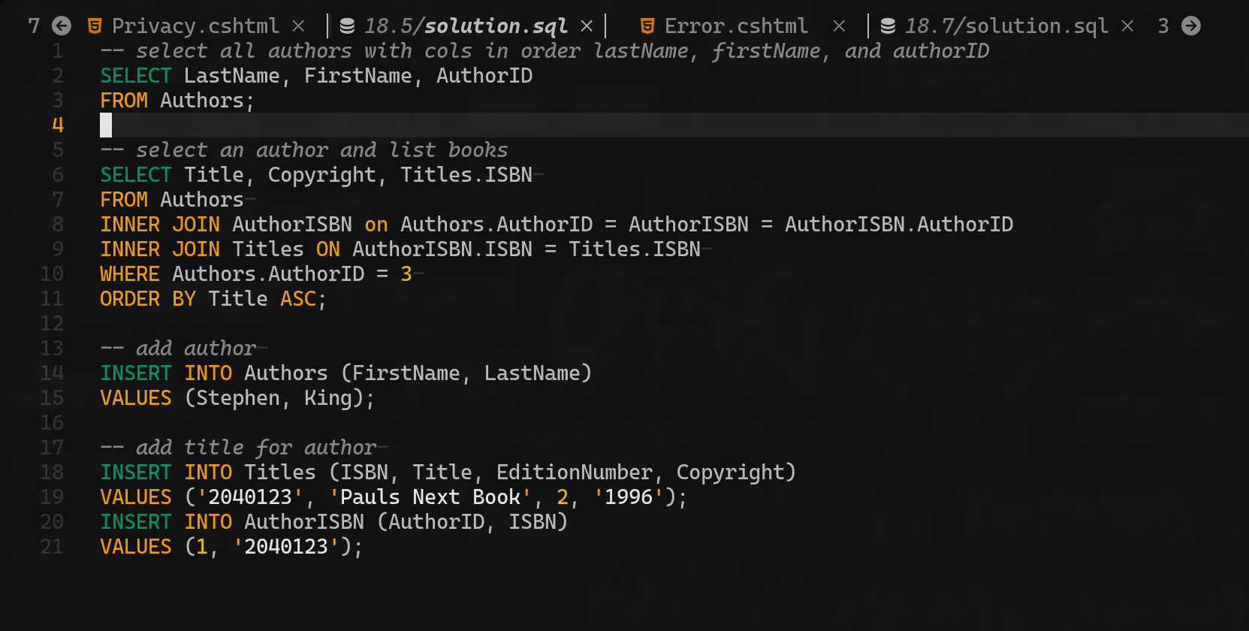

18.7
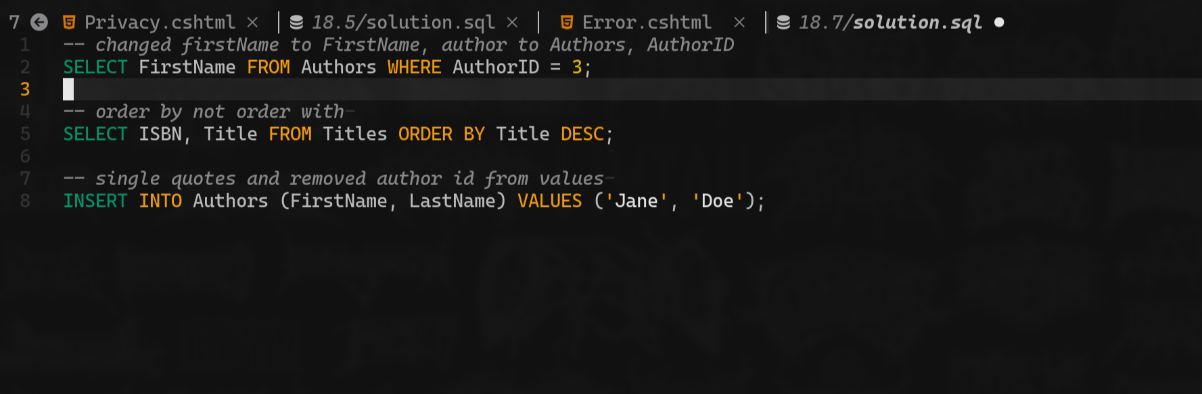

23.3
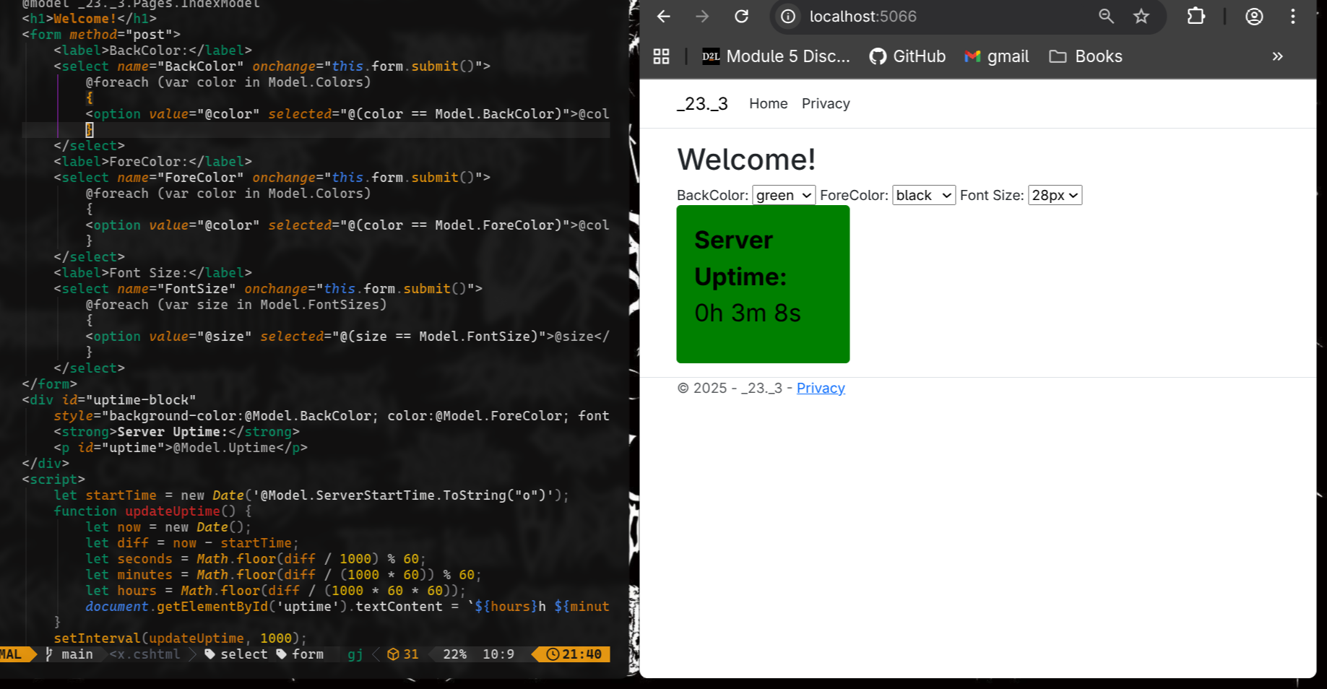
AFTER REFRESH
